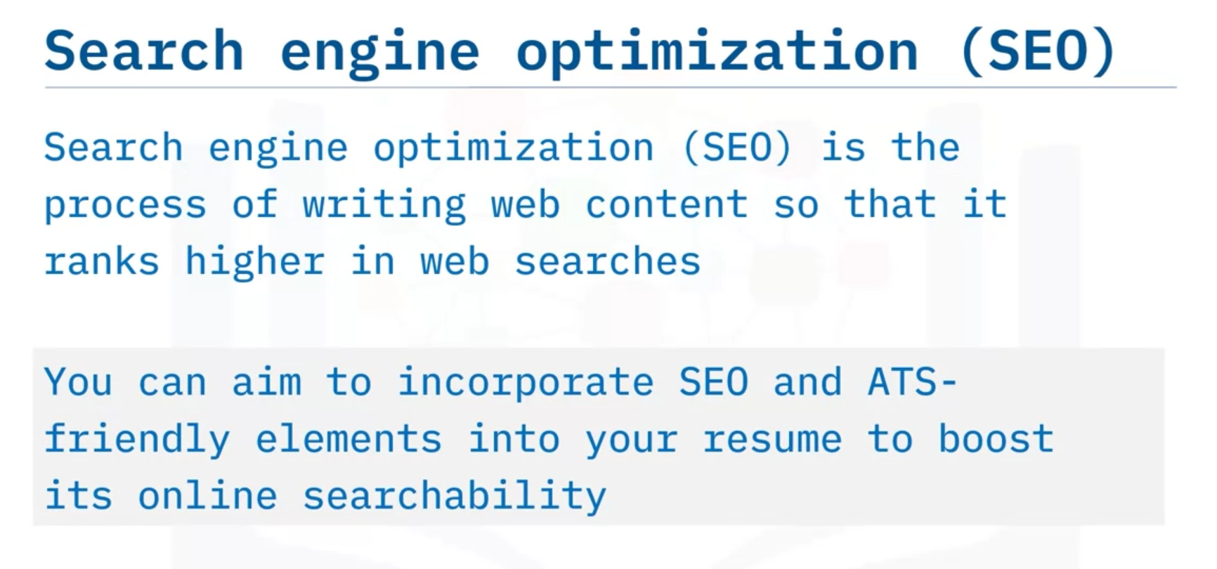

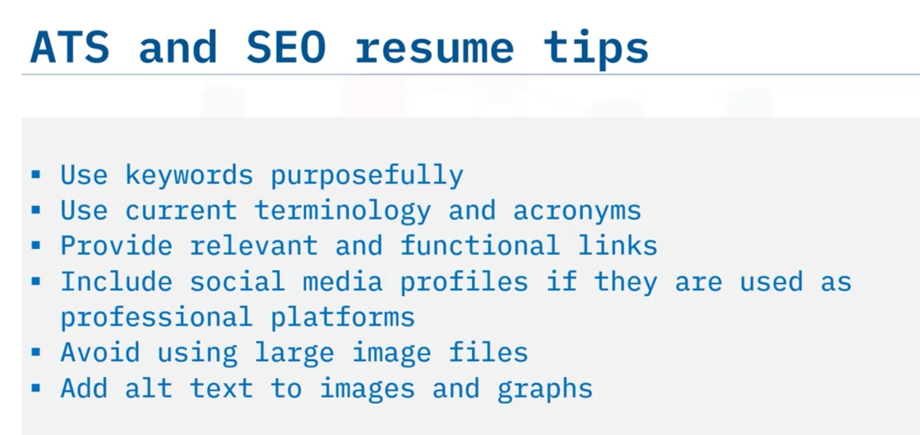

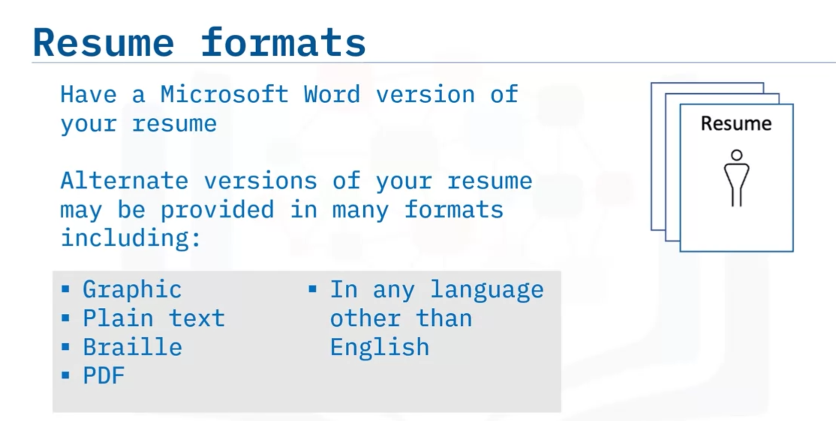

# Drafting Other Materials – Basic Cover Letter

One of the most important items to develop when you begin a job search is a basic cover letter. It’s a good idea to draft a basic cover letter before you start applying for work. You’ll adapt the letter to each position and application, of course, but you can start with a basic template.

Your cover letter will work along with your resume to introduce you to a prospective employer. It should briefly introduce you and make a case for why you would be a strong candidate for a particular position. Don’t repeat all of your qualifications – your resume will contain the details. Just include enough information to show that you are well qualified and interest the reader enough to schedule you for an interview.

To write a basic cover letter, open with a greeting and address the letter to a specific person whenever possible. If you don’t know a name, address it to the title of the person you hope will see the letter, such as “Dear Hiring Manager”. Use correct business punctuation.

### Example

Dear Ms. Ericson:

In the first paragraph, state the title of the job to which you’re applying, and why you feel you might be a good fit. It’s also sometimes useful to mention where you saw the job listed or who referred you, and it can be very effective if you can express why you are enthusiastic about the company.

### Example

I was excited when my colleague Janna Navarro told me your company had an opening for a Data Analyst 2. I have admired the products developed by Torotoni Software for many years, and I would be very interested in joining your team. I am a data analyst with 3 years of professional experience and skills that match your needs, and I think I would be a strong candidate.

Next, build a case for your strengths as a candidate. Cite a few examples from your experience that match the skills they mentioned in the job listing; draw parallels between the listing and your resume and portfolio. Quantify your experiences when possible. However, keep this brief and focused. Pick some best examples and keep some of your work to discuss further when you interview.

### Example

In my most recent role, I maintained and extended a mission-critical database and prepared a weekly report of changes and trends for stakeholders. I also worked with the coding and management teams to improve functionality of the database by 45%, advised on compliance issues, and supervised the work of 2 interns. I know SQL and Python, have intermediate proficiency in Hadoop and Apache Spark, and have used Tableau software for visualization.

Finally, close by restating your interest, say you hope to meet with them further, and then add a polite signoff.

### Example

Thank you for your consideration. I would love to bring my skills to Torotoni Software, and I’m eager to discuss the contributions I can make to your team.

Best regards,

Olivia Torvald

On a practical note, you will want to save your letter in Microsoft Word format because many companies prefer it. You will also need a plain text version so that you can easily copy and paste the text into an online application form. It can also be useful to save it as a PDF file (although you’ll have to create a new version every time you modify the letter). Have a friend proofread your letter so that you’re not embarrassed or even eliminated because your letter is full of errors.

Writing this letter in a modular and straightforward way will make it easier to adapt later, since you will want to change some of the text to fit each role you apply to. Like a news story or a headline, writing clearly and concisely will catch the interest of a hiring manager; making a good case for yourself as a candidate will motivate them to read your resume and, hopefully, call you for an interview.

# Drafting Other Materials

In addition to your resume and portfolio, you’ll find it useful to have some other materials at hand when you prepare to look for work. Having these resources on hand will help make the process faster and easier. In this course, we’ll discuss three materials in particular:

* A basic cover letter that you can tailor for each position you apply to
* An “elevator pitch,” which is a short description of who you are and what you’re looking for that can be useful in many situations
* A list of references who can vouch for your past experience

All of these will be useful, so it pays to work on them at the beginning of your job-seeking process.

## References

Let’s begin with references. Many employers will ask you to provide references at some point in the interview process, so it makes sense to collect them ahead of time. This will also give you a chance to contact your chosen references to make sure that they are willing to talk to prospective employers on your behalf. You can also gather current contact information and their permission to share that information.

Generally speaking, you will need from each reference:

* Name
* Title
* Company
* Mailing address
* Phone number
* Email address

Be sure to keep a directory of your references with their contact information somewhere you can easily find it.

**Professional references** are people who can comment on your past work history. Usually, they should be managers who worked with you and can discuss what you did at past jobs. Note, however, that some managers are prohibited by company policies from discussing the details of your work and can only verify that you worked at the company and your start and end dates.

Most employers will prefer to talk to your supervisors as professional references, but you can also list:

* Colleagues if they worked closely with you.
* Professors who are familiar with your classwork if you have a short work history.
* People who have supervised or worked with you on a volunteer project.

**Personal references** are people who can talk about your personal character, trustworthiness, honesty, work ethic, and so on. These are rarely needed in modern interviews, but it doesn’t hurt to gather some just in case. They should be people who know you well but are not part of your family. As with professional references, gather their contact information and make sure they don’t mind being contacted.

# Drafting Other Materials – Elevator Pitch

An “elevator pitch” can be one of your most effective tools. It’s a short, easily memorized statement that describes yourself, some of your key features as a job seeker, and your goals. You can use it in a spoken or written context to help introduce yourself effectively.

Even though employers are unlikely to ask you for an elevator pitch directly, having one ready will help you in many situations. It can help you draft a cover letter, speak easily to a potential hirer when you network at an event, answer general interview questions such as “tell us about yourself,” and so on. In an interview, it will help you seem poised and prepared.

Your elevator pitch should answer three questions:

* Who are you?
* What do you do?
* What do you want?

## Example

“Hi, I’m Jonathan Bittmann. I’m a data scientist working toward a move into management. I’ve spent the last six years as a data analyst for a cloud development company, where I’ve developed my skills in programming and served as team leader. While leading several successful project teams, I became interested in data science management and have gone back to school to earn a business administration degree. While I’m working on that, I’m looking for a position in project management so I can put my learning to use. I’m very interested in the work your company does and I think I could bring a lot of expertise and leadership to your organization. Could we meet to discuss the open project manager roles you currently have?”

Let’s break it down and see how you can write an elevator pitch of your own.

Who are you?  
Start by introducing yourself with your full name and add your preferred name if you have one. If you’re in a face-to-face situation, this is a good time to offer a handshake. Follow this with a statement about your career title and current situation.

What do you do?  
Provide a few key pieces of skill or experience that set you apart and make you an interesting candidate. Don’t try to list your whole resume – pick a highlight or two about your recent experience. When you’ve decided on your points, arrange them in a way that makes sense; you want to tell a story, not just list bullet points. Making a story out of your points quickly engages your reader’s or listener’s interest.

What do you want?  
Finish with an action request. This could be asking for an interview, stating why you’re interested in a particular position, or even just asking whether your statement covers the question they were asking. The idea is to encourage the other person to engage with you, not just listen to what you’ve said. This will definitely depend on the context and setting, so think of a few possible endings.

While you’re composing your elevator pitch, use natural-sounding language and avoid jargon. You should sound comfortable when you speak it, so remain professional, but use your own phrasing. Additionally, your pitch should be easily understood by many people; this will make it useful in many situations.

After you write your pitch, work to memorize it. Practice your pitch until you are comfortable and can easily deliver it verbally. Slow down and speak clearly. Being nervous will likely make you speak more quickly, so practice slowing down and enunciating. Find a friend who will help you memorize it and practice speaking it. Maybe you can work together on developing elevator pitches for both of you.

You’ll want to be able to use the pitch in many situations, but sometimes it will make sense to tailor it to the context you’re in, such as changing what you request or highlighting slightly different experience. Write the pitch so that it’s broadly useful but be ready to tailor it as needed.

An effective and well-rehearsed elevator pitch can be extraordinarily useful in your job search. The payoff for having one ready can be enormous, so it’s well worth investing the time to develop one.

**Week 2**

**Applying and Preparing to Interview**

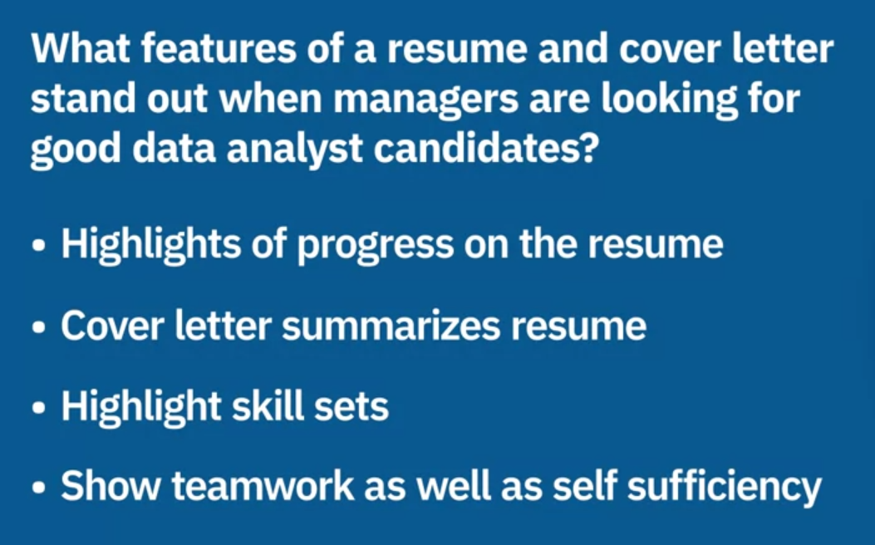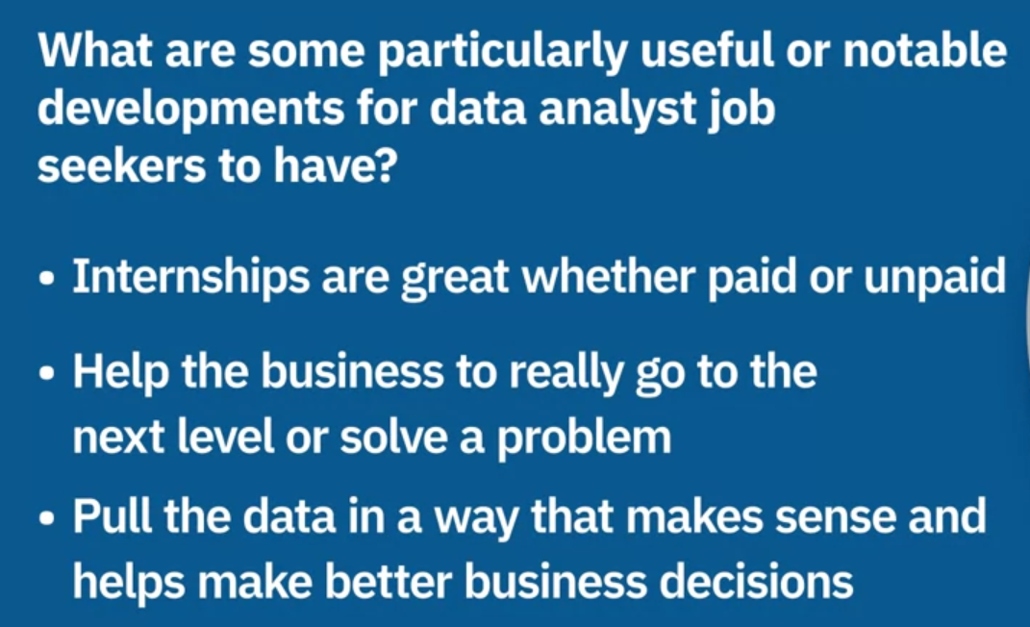

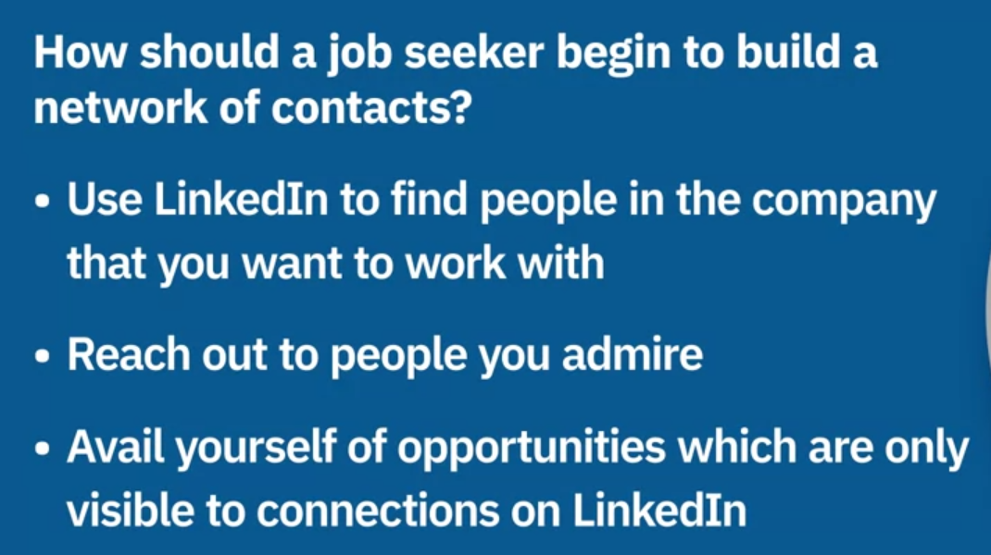 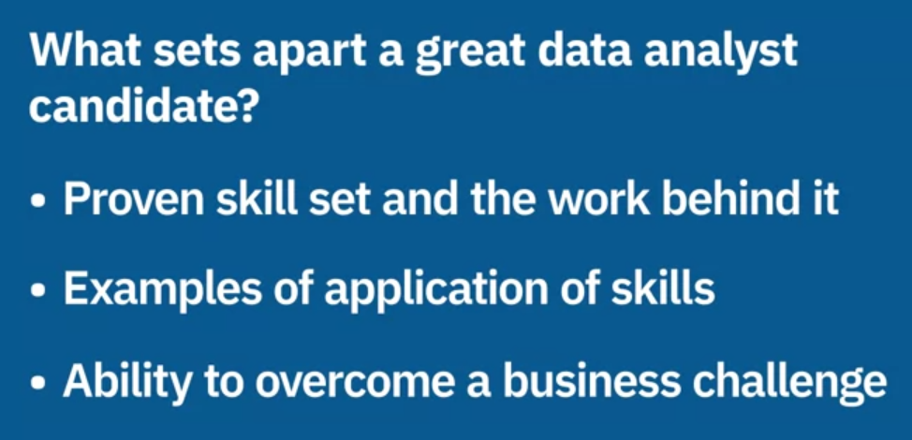

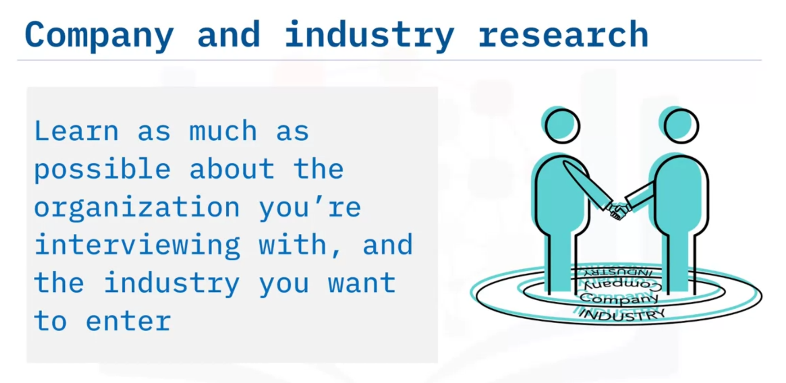

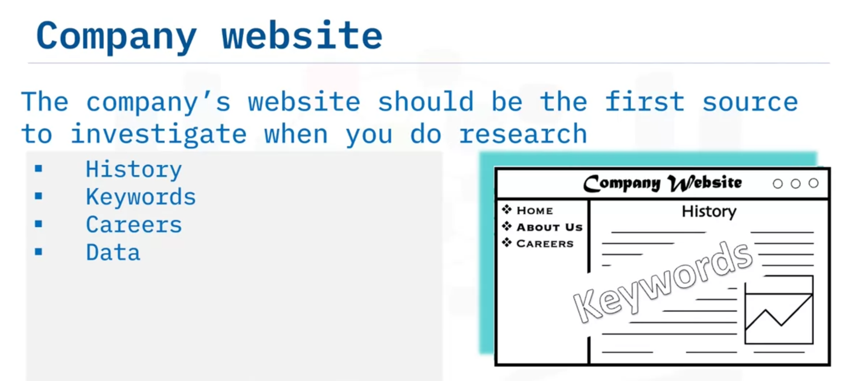

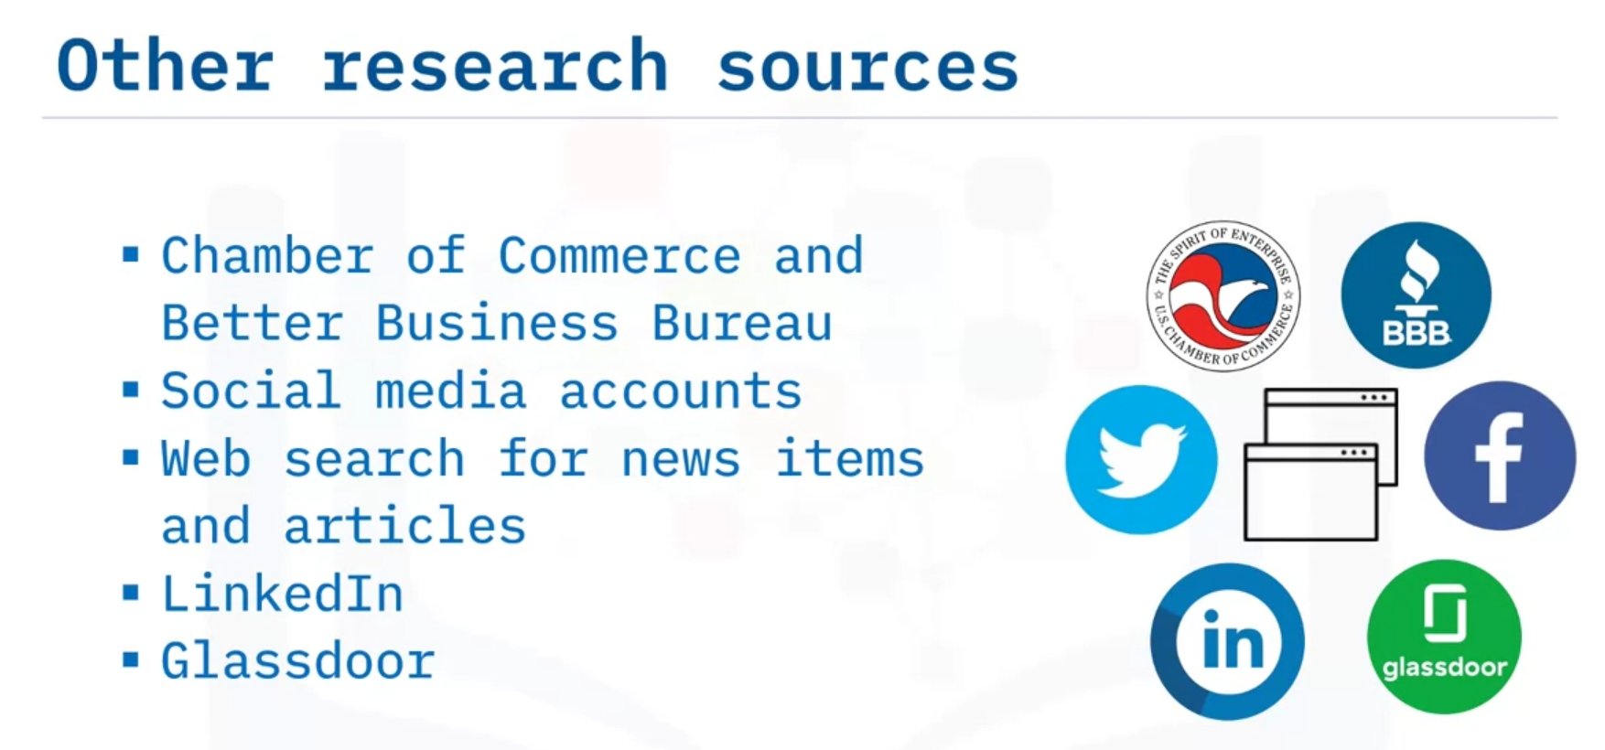

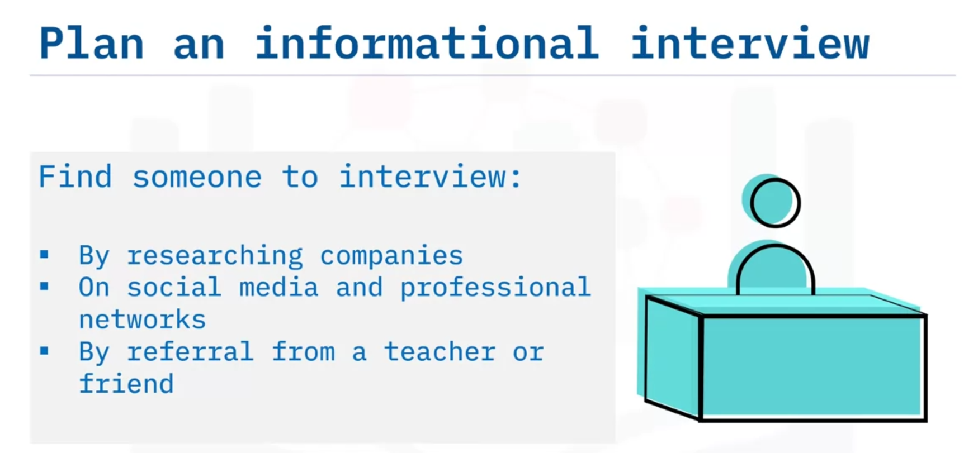

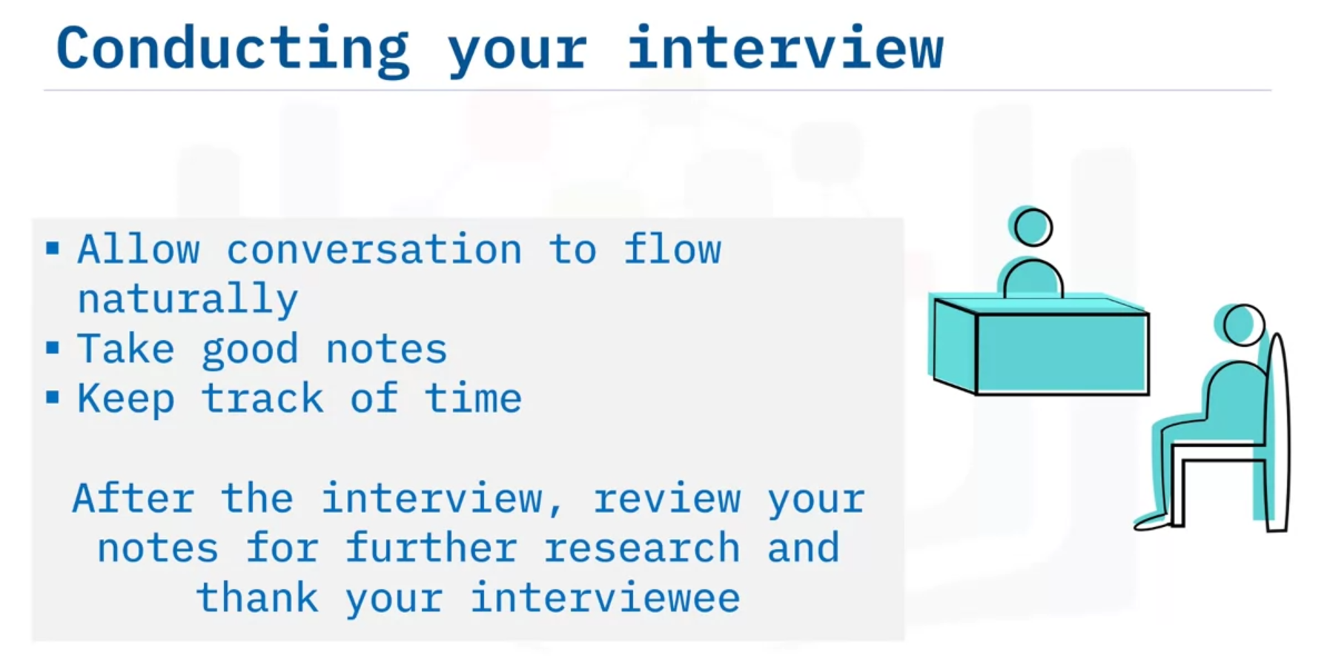

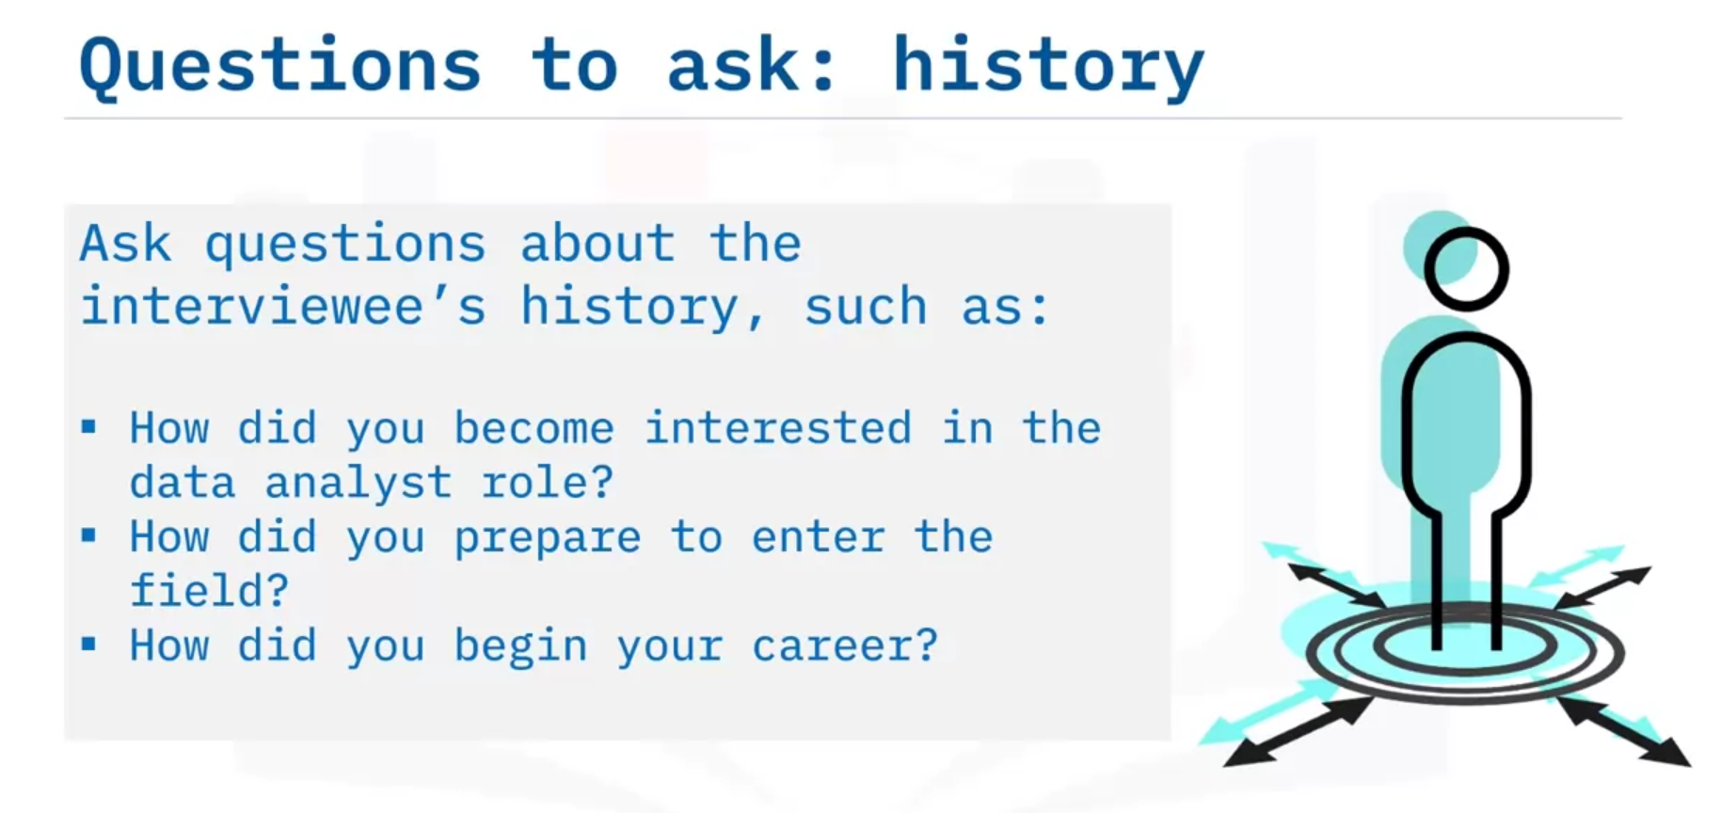

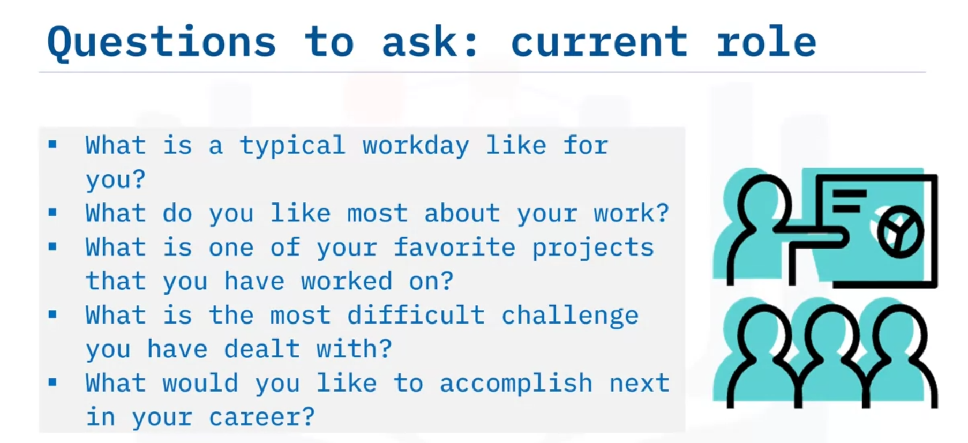

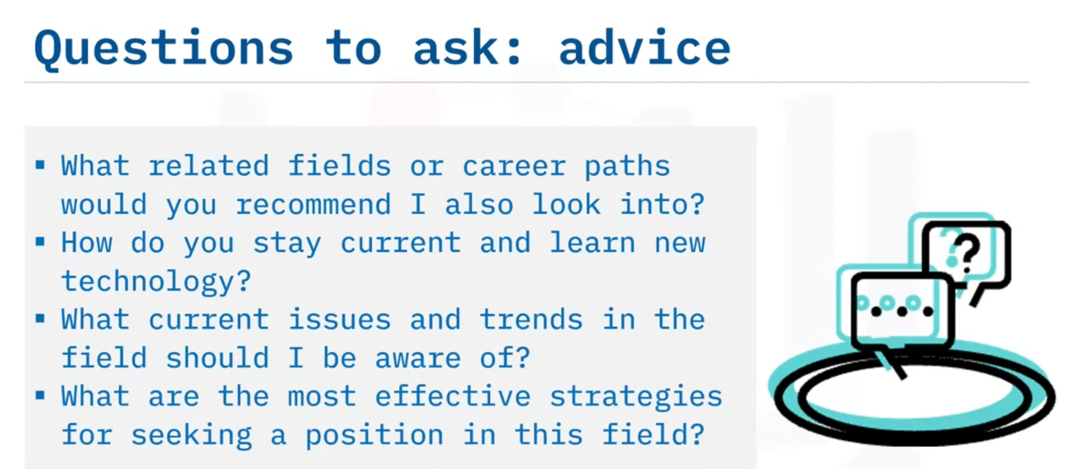

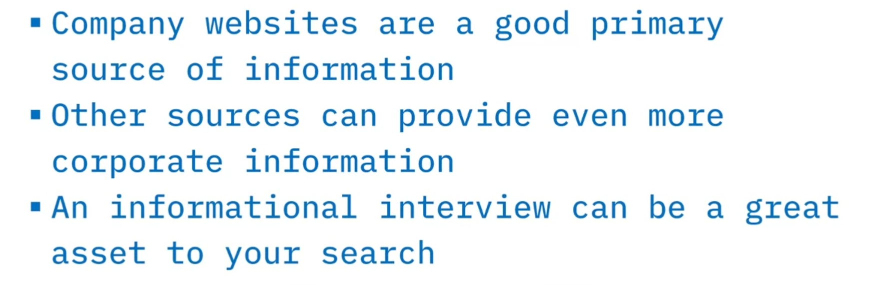

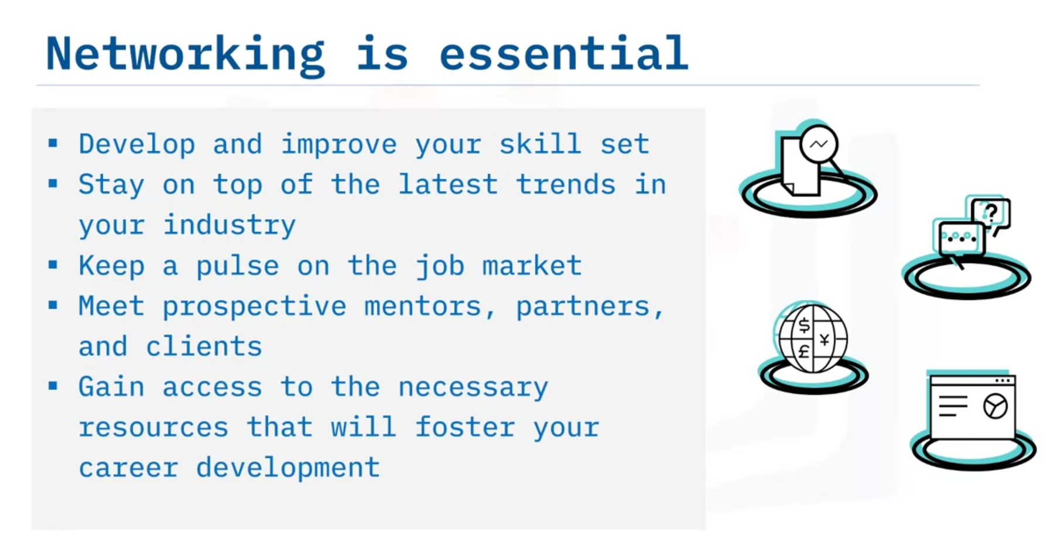

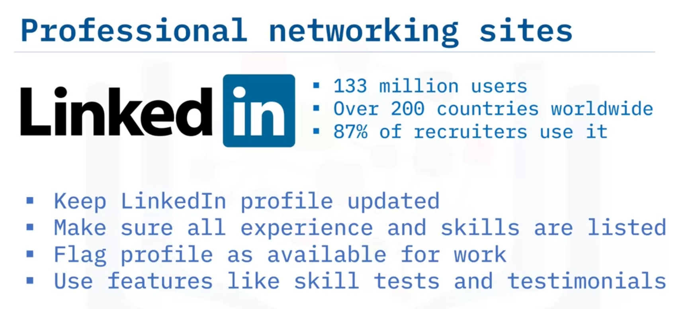

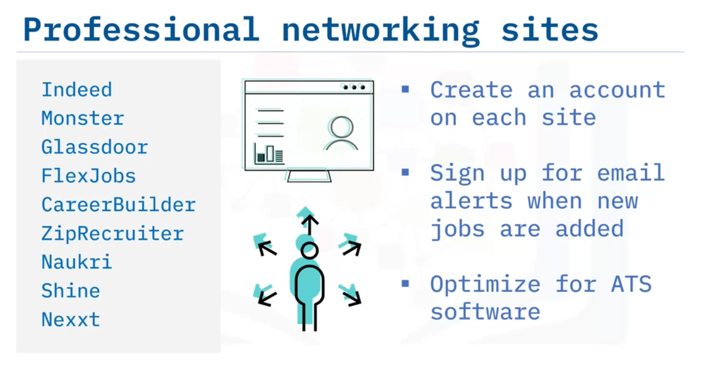

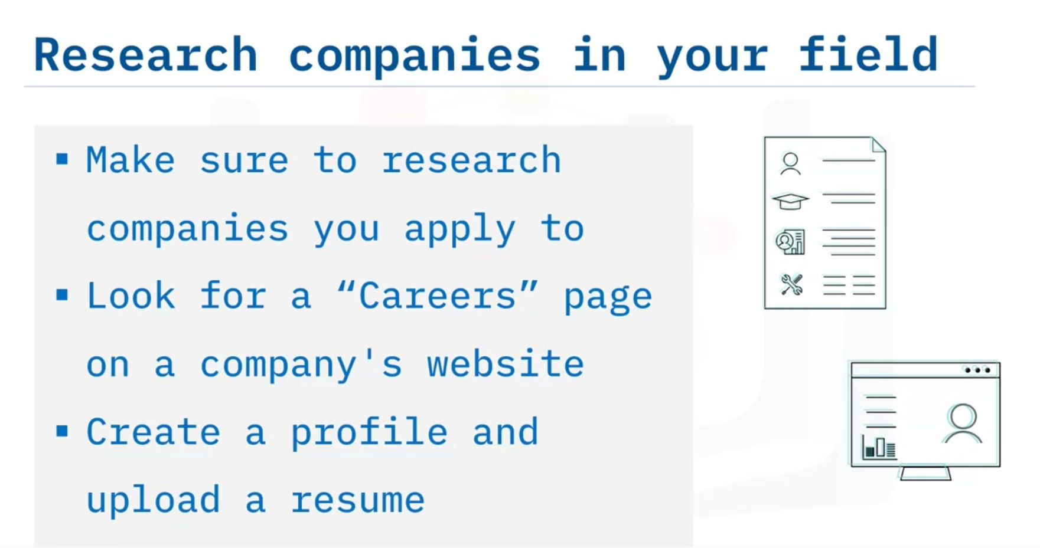

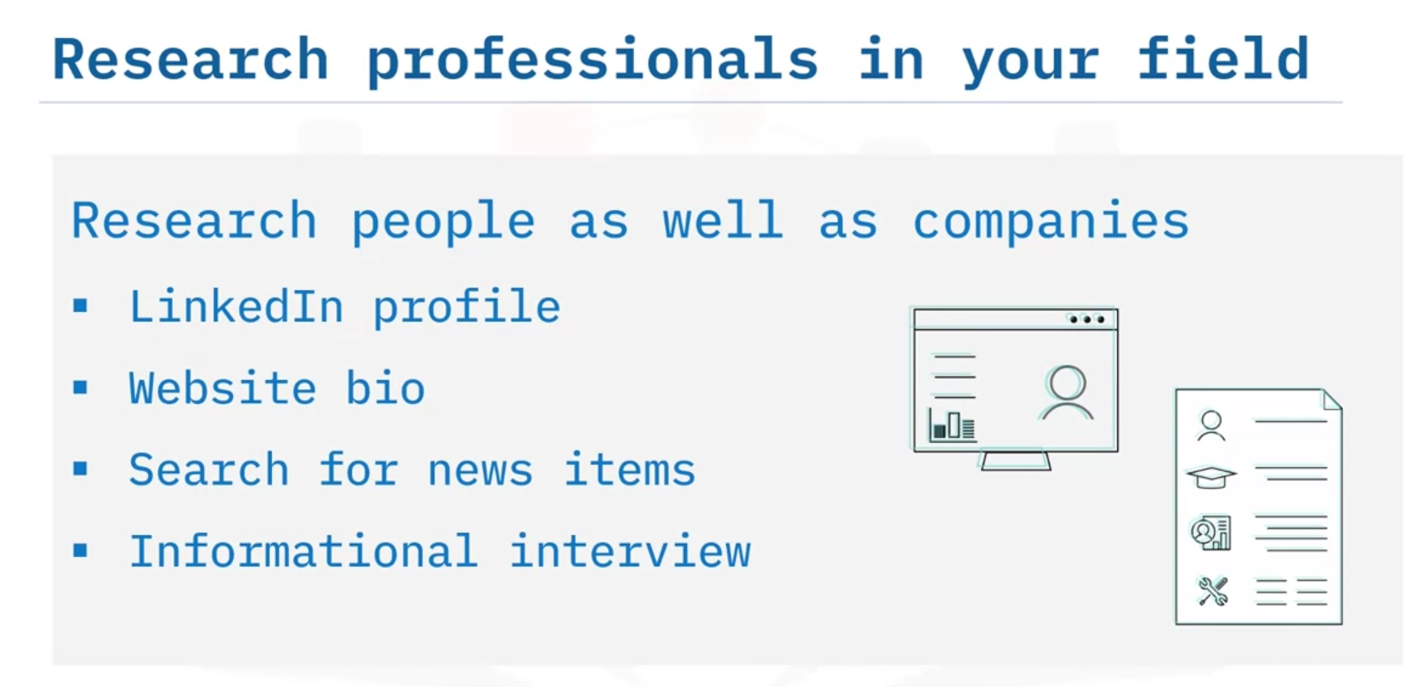

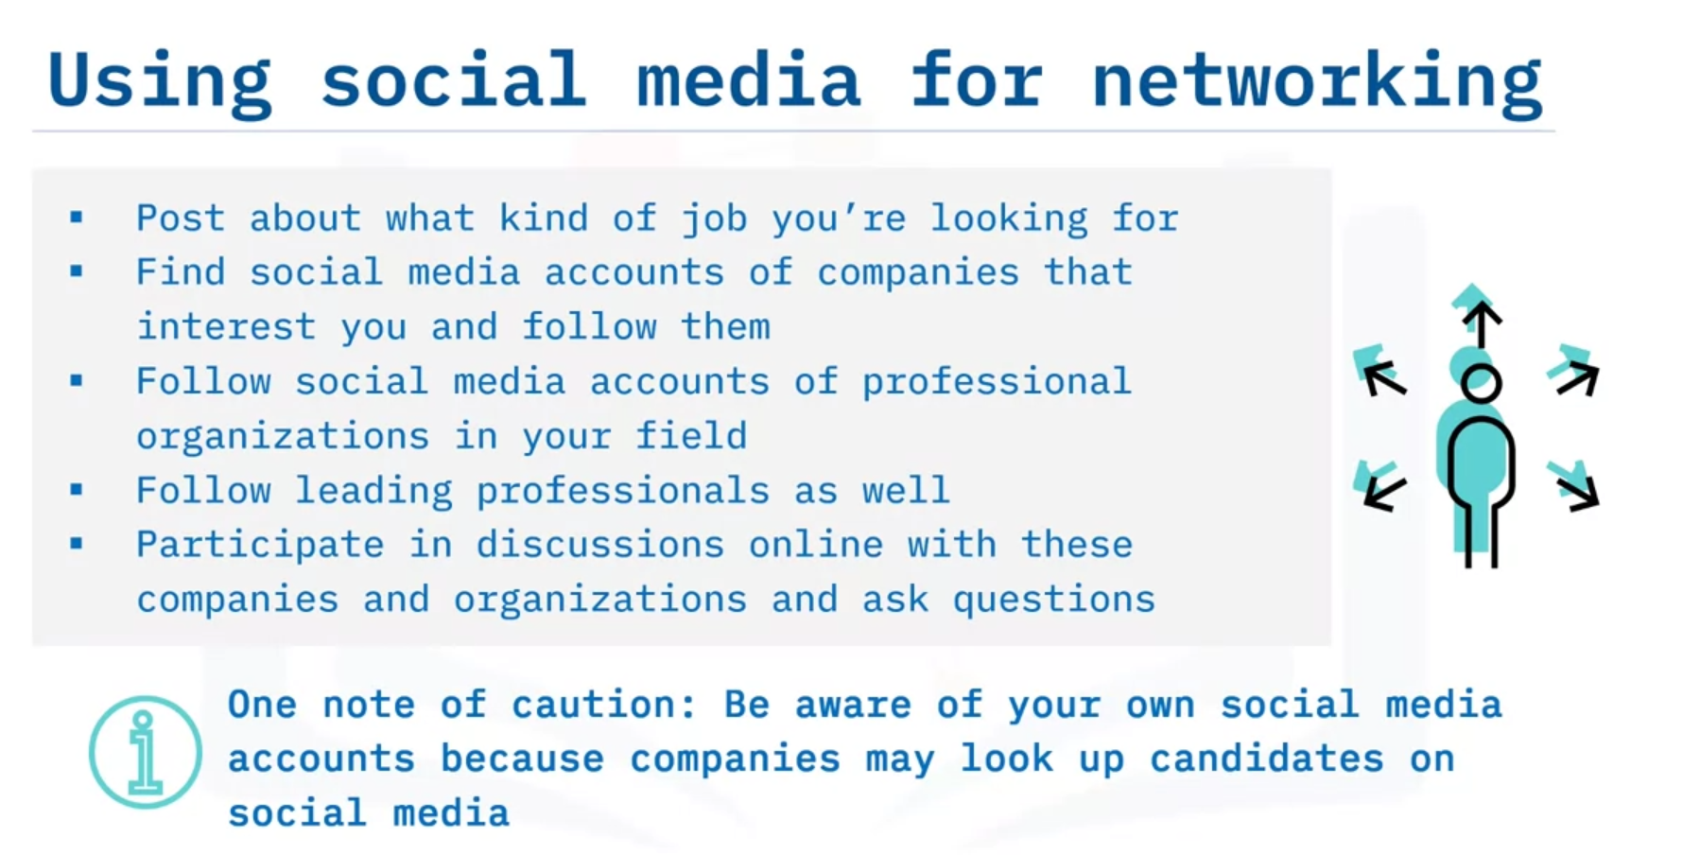

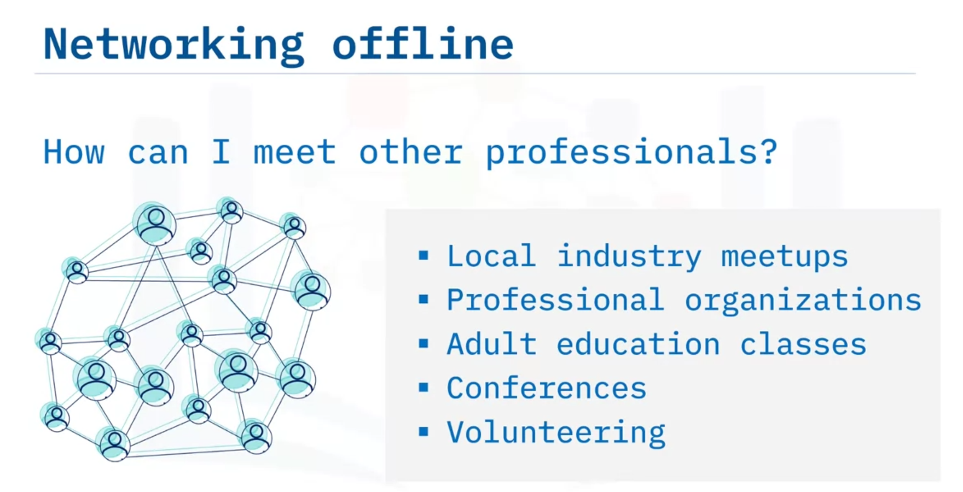

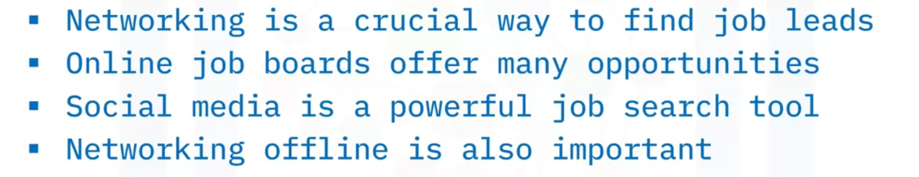

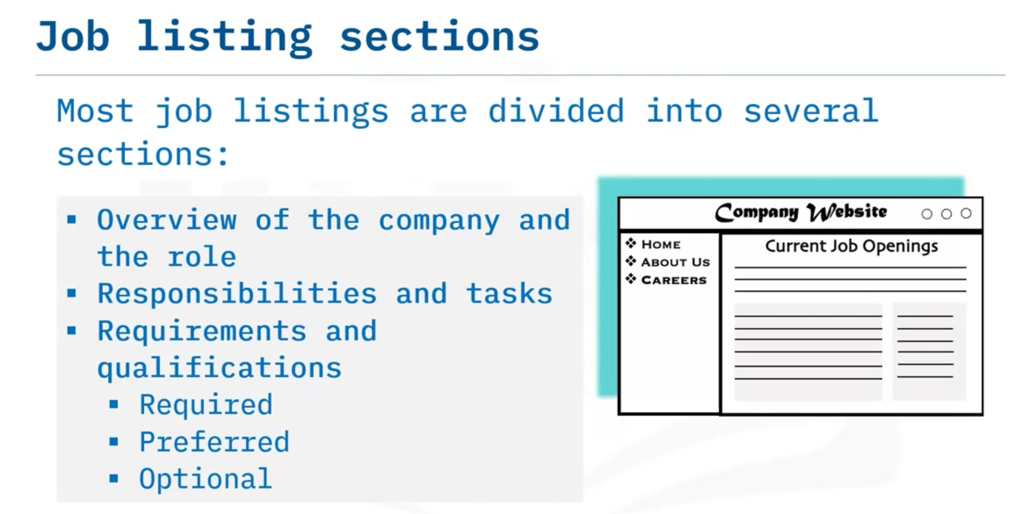

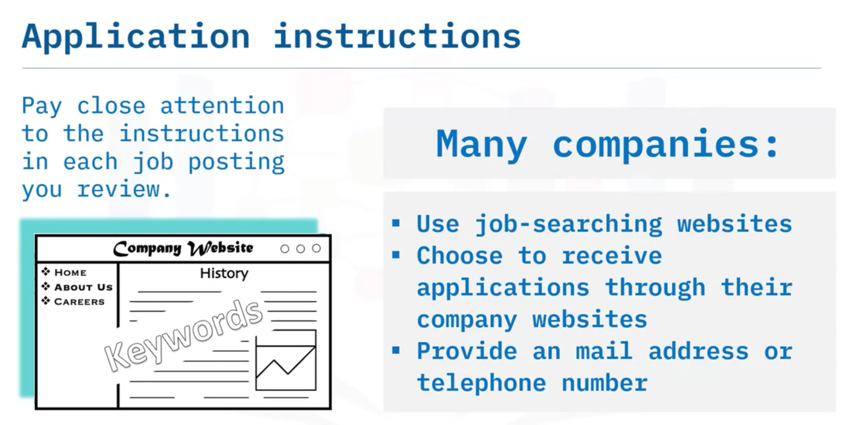

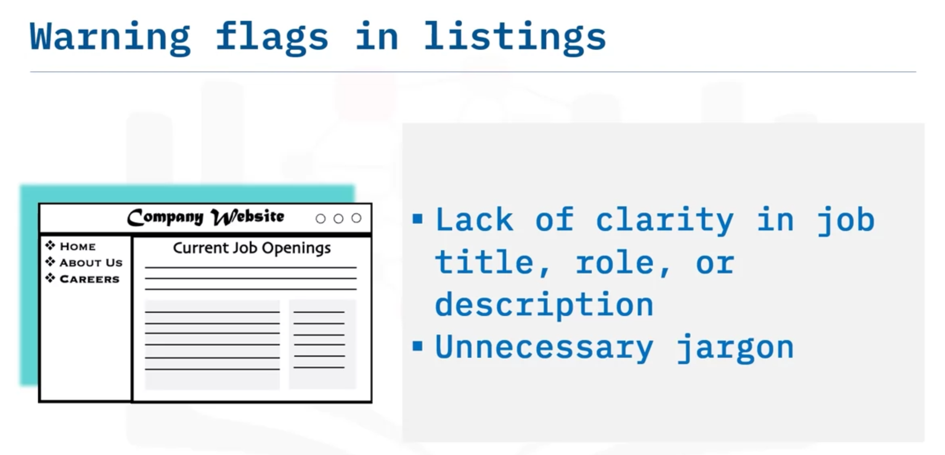

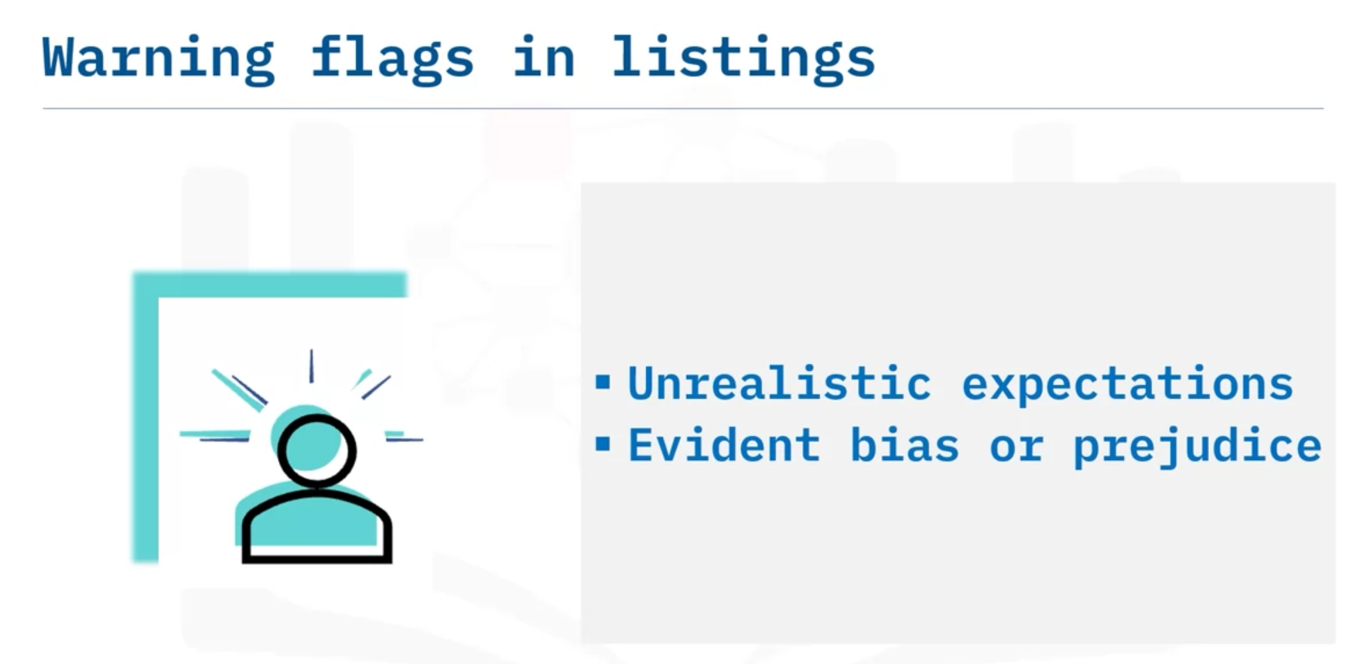

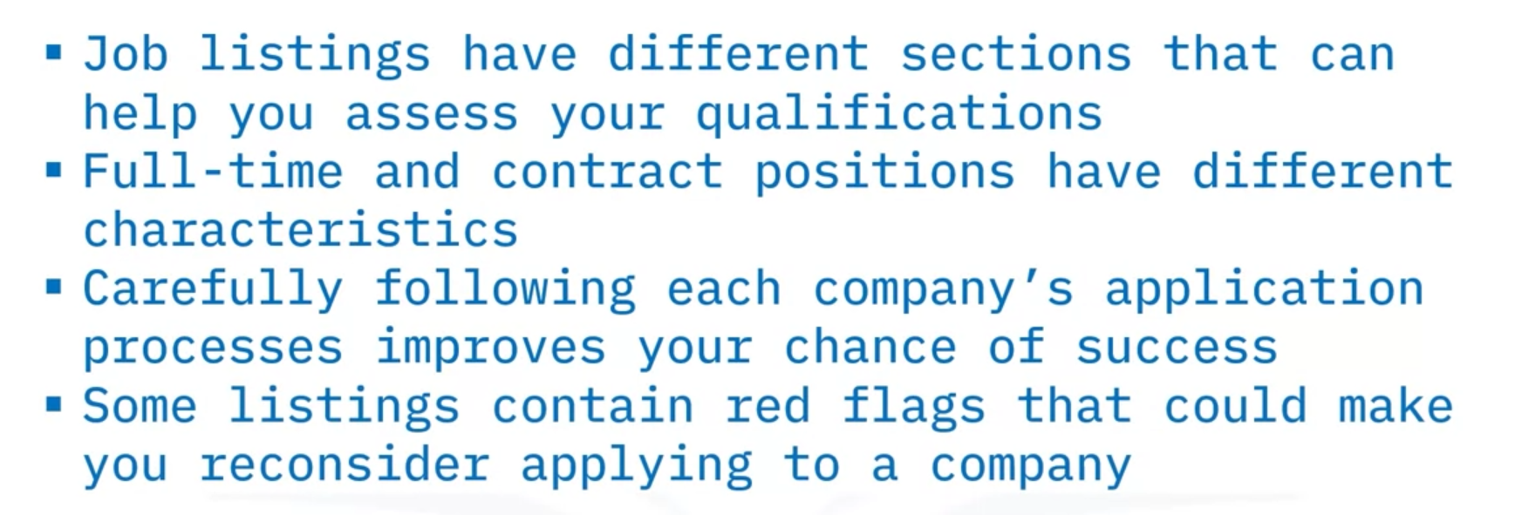

# Apply for a Job

When you’ve found a job listing for a role that interests you, and for which you are well qualified, it’s time to consider how to apply for the job. Navigating a company’s application process can be tricky, however, and each company has its own procedures. If you read carefully and consider your application materials thoughtfully, you can make an application that stands out.

First of all, read the listing to see whether the company prefers you to fill out an online application, use a website application process (such as on LinkedIn), send a resume and cover letter to an email address, or some other procedure. Follow the directions very carefully and do exactly as they say. If you don’t, your application may be disqualified and never seen by the company’s hiring managers.

Generally speaking, there is no limit to the number of applications an aspiring job candidate can submit, especially if the job search targets different companies. However, some companies limit the number of applications you can send in a particular time period, so you’ll need to be strategic in that case and choose the jobs that are the most interesting to you.

There may be other strategic considerations. When you are interested in multiple positions within a company, whether it’s better to focus on one application or apply for multiple open positions can depend on several factors. One approach would be to apply first for the position you believe you are most qualified for or that interests you most. After applying, contact human resources (HR) or a hiring manager to ask for advice about whether you should apply for each job you are interested in or if it’s best to avoid duplicate application submissions. They should be able to tell you whether your application can be forwarded or whether the company allows you to create a profile that lets you easily apply for multiple jobs.

### Resume and cover letter

In almost every case, you’ll need to send a resume, and in most cases you should send a cover letter, even if it isn’t required. If you’ve already drafted basic versions of these two documents, you’re in a good position. You will need to edit them to fit each job, but you won’t need to start from scratch. Work carefully and make sure you include information that shows your skills and experience to advantage for each specific role.

* **Resume** – Double-check for these potential problems and any others you may spot:
  + Outdated or missing contact information
  + Grammatical and formatting errors
  + Using an unprofessional email address
  + Cliche vocabulary or jargon
  + Unrelated job experience or irrelevant hobbies
  + Attaching a photo of yourself (your resume should not contain a photo)
* **Cover letter** – Be careful to check for these issues:
  + Grammatical and formatting errors
  + Too long (multiple pages) or too brief
  + Addressing the wrong person or misspelling a name
  + Not tailoring the letter to the specific company and job opening
  + Tone is arrogant or too humble—try for a professional, confident tone
  + Listing references in the letter
  + Explaining the reason(s) why you are no longer working for your previous employer or including other issues that will be better to discuss in an interview if necessary

### Other application materials

In addition to a copy of your resume and cover letter, a potential employer may request other documents to validate your qualifications such as educational transcripts, writing samples, portfolios, certifications, a list of your references, and letters of recommendation. Supporting documentation will vary among hiring companies and job positions. Be sure to follow all the instructions provided by the company to avoid submitting an incomplete job application.

* **List of references** – Look out for some common mistakes applicants make with their lists:
  + Providing it too early (if it is not requested, save it for later in the screening process)
  + Failing to notify your references that they may be contacted by hiring employers
  + Providing incorrect contact information
* **Letters of recommendation** – Avoid presenting a letter with the following errors:
  + Too vague or generic content
  + Lacking information that validates your work
  + Any letter that expresses reservations, especially if it is not counterbalanced with mentioning any positive qualities
* **School/college transcripts** – Do not provide a copy of your transcripts if the hiring company has stated that you must request a sealed copy be sent directly to them by the educational institution.
* **Online portfolio’s URL** – Verify that the URL is correct and that the link is valid and provides work samples that are recent and properly documented.
* **Work or writing samples** – Check for these common errors:
  + Grammatical errors
  + Does not show your work effectively
  + Cliches or overuse of buzzwords
  + Too brief or too lengthy
* **Certifications (trainings, licenses, and others)** – Verify these features:
  + Valid signatures, seals, or logos are present
  + If the certificate includes an expiration date, make sure it is still current
  + Only include relevant certificates that support your academic or experiential qualifications for the job position

Document naming and organization  
Before uploading a PDF or other formatted files, make sure that you have used a consistent naming convention for your files. Include your full name as part of the file names. For example, if your resume is contained in an electronic file with the name “John_Smith-Resume.pdf,” then name the rest of your supporting documents “John_Smith-Cover_Letter.pdf.” This helps the recruiter identify all the files that were submitted by you. Use the following rule of thumb: name your files consistently and in a way that, if sorted alphabetically, all of your files will remain together in a file search. For example:

| **Name** | **Date modified** | **Size** | **Kind** |
| --- | --- | --- | --- |
| John_Smith-Cover_Letter.pdf | April 4, 2022 at 2:20 PM | 302 KB | PDF Document |
| John_Smith-References.pdf | March 14, 2022 at 2:44 PM | 45 KB | PDF Document |
| John_Smith-Resume.pdf | May 12, 2022 at 8:01 AM | 224 KB | PDF Document |
| John_Smith-Transcripts.pdf | May 3, 2022 at 3:02 PM | 362 KB | PDF Document |

Limit your special characters to underscores and/or hyphens. If you incorporate blank spaces in your file names, be sure to use them consistently. Do not include version numbers as part of your file names and be sure to submit all of the requested documents at once.

It may be convenient to create a template for your cover letters. Include your name, job title, and contact information. Use a cover letter you have already written and identify the customized information. Highlight it to ease the process of tailoring a subsequent letter for a different position title or company. Save the template letter with the word “template” included in its name and use it as needed. Once a new tailored letter is written and ready, save the file, replacing the word “template” with the name of the company or the job title you are applying for.

Conclusion

Remember that a cover letter is a one-time opportunity to create a first impression. In one page, you must provide information about your qualifications and career aspirations in a way that compels recruiters to learn more about how your skills and experience, and to see if your goals align with the company’s own mission and goals. It is equally important to include quality content in your letter as it is to present it free from unfortunate, but very common, errors found among online job applications today. Correctness and accuracy in all of your supporting documents complete the image you project and will help you stand out from the competition.

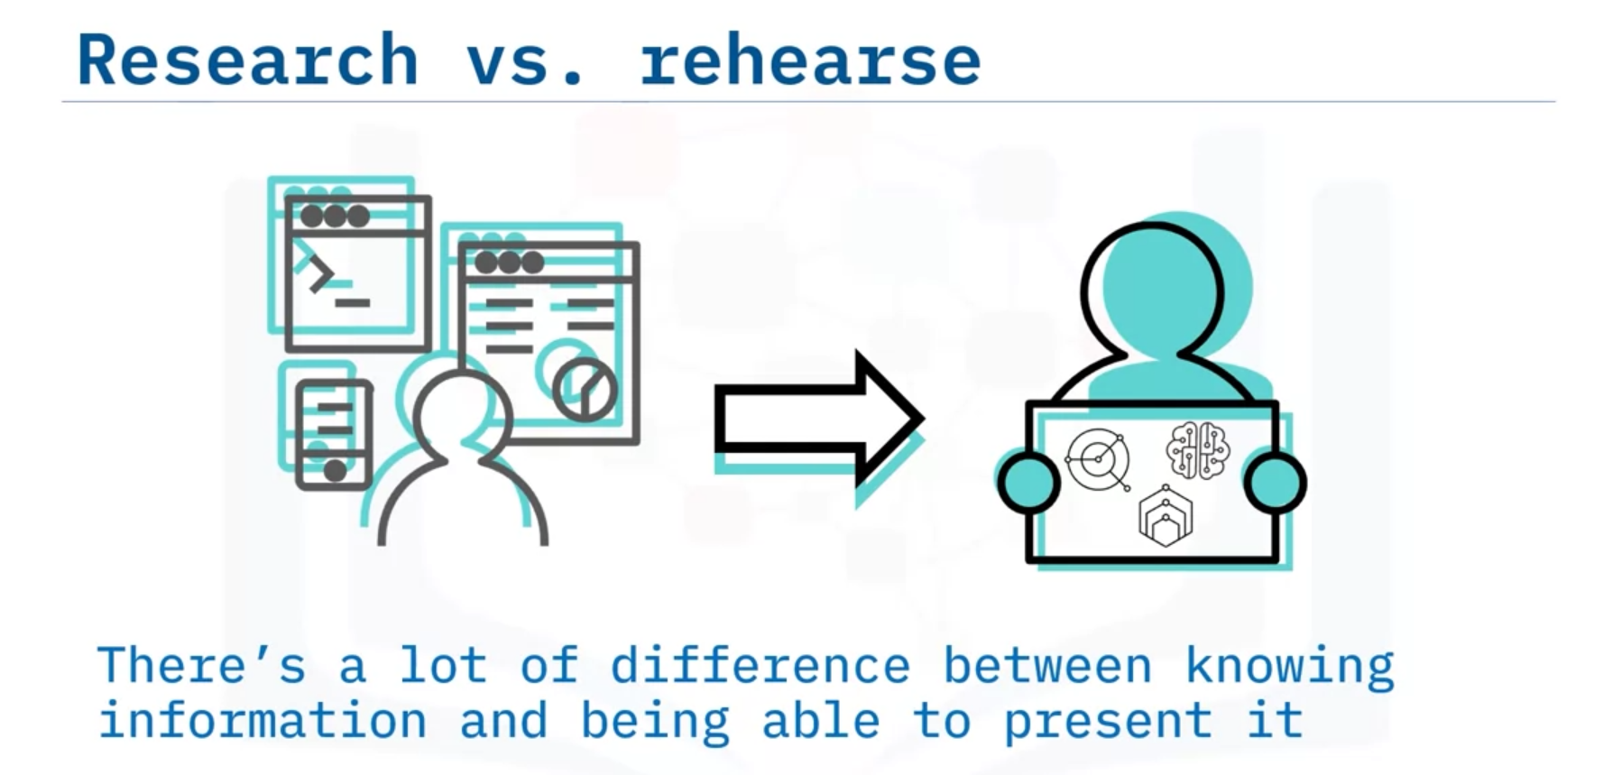

3-4 sentences:

